Man in the Mirror
SUFFOLK ASAFA Lions Club Leg. DuWayne Gregory
is offering…
FREE EYE EXAMS
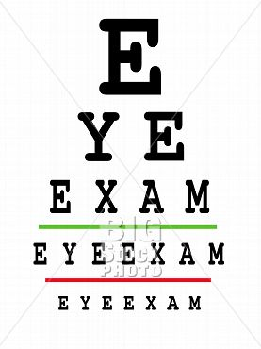
SATURDAY, JANUARY 16, 2010
8-11 AM
WYANDANCH HIGH SCHOOL

